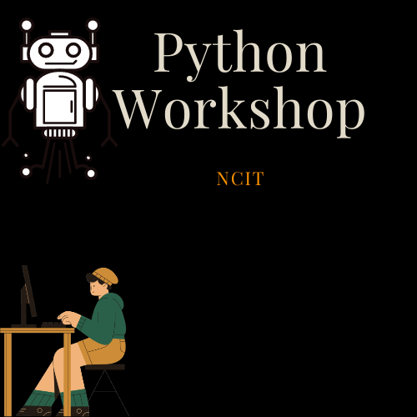

Python Workshop (QnA)

NCIT- BALKUMARI

Created by:- Kushal SB Date:- 12/5/2021

Introduction

This workshop is designed for Python enthusiasts who want to learn and improve their skills in Python Programming. The workshop is organized by Students of NCIT with the intent to help each other improve**. I have attempted here to answer some of the questions that participants might have regarding the nature of Workshop.**

**What is Python?**

Python is a high-level, object-oriented and interpreted programming language. It was created by **Guido van Rossum** and first released in February 20, 1991.

The Creator of Python has summarized his goals for Python as:

* an **easy and intuitive** language just as **powerful** as those of the major competitors;
* **open source**, so anyone can contribute to its development;
* code that is as understandable as **plain English**;
* suitable **for everyday tasks**, allowing for short development times.

**How difficult is Python?**

Python is considered a great starter language as basic operation in Python are fairly **simple and direct**. Due to the direct and simple nature of the language, writing code in Python is faster and more **easily understandable.**

**What is the Scope of this Workshop?**

**Beginner** to **Advanced**. Meaning to say, the workshop will start from the very basics of Python. Understanding the basics is very important as without true grasp of basic operations, we can’t really design more intricate systems.

The workshop will then focus on more useful skills such as implementing **data structures and algorithms** and after completing that we focus **on Web Development, Machine Learning and other realistic applications.**

**Who can join the Workshop?**

The only requirement for joining the workshop is to have a **passionate desire** to learn.

**Who should not join the Workshop?**

If you don’t have the above mentioned requirement you should not join the Workshop.

**What does the Workshop expects from you?**

**Good behavior**

**Active Participation**

**What can get you banned?**

Scamming and trolling people.

Bringing **politics inside workshop**.

**Can I participate even if I am active politically?**

Yes, Of course you can.

**How to join the Workshop?**

You can submit an application to join the workshop **digitally** by completing the form or you can **physically** join the workshop by attending workshop (you can provide relevant details onsite).

If you have any further inquiries, contact me at- [kushal.191517@ncit.edu.np](mailto:kushal.191517@ncit.edu.np) using your college email id.